|  |
| --- |
| Functional test cases -  Amendment |
| DMS H7 |

|  |
| --- |
| Test Scenarios – Amendment  May 2021 |
|  |

# Document version

|  |
| --- |
|  |
| Document version:   |  |  |  |  | | --- | --- | --- | --- | | Version nr. | Dato | Created by | Updates | | 1.0 | 11-05-2021 | Emma Hagerup |  | |

Table of Content

1 Document version 1

2 Introduction 3

2.1 Test data and preconditions 3

2.2 Process flow 3

2.3 Test Scenarios 4

3 Detailed test scenarios 5

3.1 Scenario 1: Amendment application rejected based on format validation 5

3.2 Scenario 2: Amendment application rejected based on content validation 5

3.3 Scenario 3: Amendment application with notification of granted request 7

# Introduction

The purpose of this test is that the Economic Operator (EO) can make changes on an already existing declaration which has been presented. This is called an amendment. An amendment is sent by the EO to the DMS ERMIS system. A declarant can be allowed to make changes on a declaration where the goods are not yet released or even if the goods are already released. The change can however not be allowed if they affect other goods than the original declaration included.

Further, amendments cannot be allowed if:

* The Customs authority has notified the declarant that they intend to investigate the goods.
* The Customs authority have established that the information in the declaration is not correct.

## Test data and preconditions

To be able to do execute the functional test cases for amendment, the EO must have established a connection to the DMS test system, following the Connectivity Guide. Second, the EO must send a declaration followed by an amendment. This must be done using the following services:

* DMS.Import.Declaration.Submit
* DMS.Import.Declaration.Amend

To endpoint:

* https://secureftpgatewaytest.skat.dk:6384/exchange/CVR_<CVR>_UID_<UID>

## Process flow

The process flow for an amendment application of an already existing declaration can be seen in Figure 1 below.

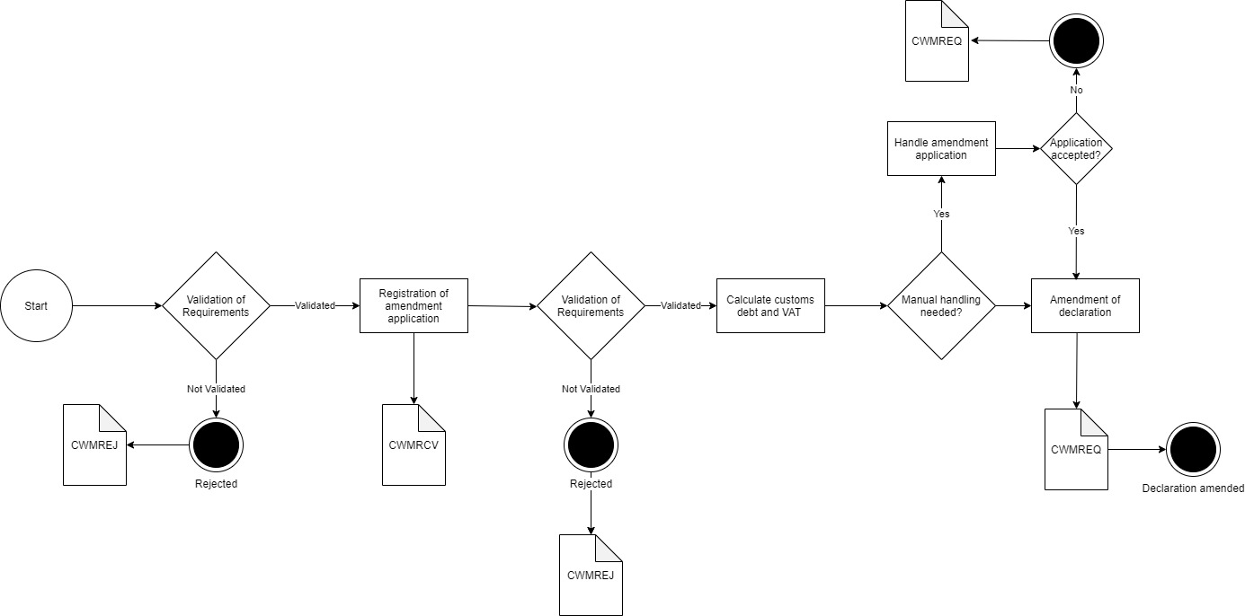

Figure 1

## Test Scenarios

To complete the functional onboarding phase two, the OE must deliver confirmation of passed test-cases for each test scenarios:

|  |  |  |
| --- | --- | --- |
| **Test no** | **Test Scenario** | **Passed** |
| **1** | Send amendment application which is synchronously rejected based on format validation | ☐ |
| **2** | Send amendment application which is rejected based on content validation. | ☐ |
| **3** | Send amendment application and receive notification of decision on request | ☐ |

Figure 2 shows the process flow divided into the above mentioned 3 scenarios.

Figure 2

# Detailed test scenarios

The following sections will describe the aim of the specific test scenarios and it will provide the desired results of the test. It should be noted that there can be changes in the notifications provided by the DMS solution, because the solution is still in development. If at a later point more notifications will be added the EO will be informed about this and the EO will be requested to complete the test again.

## Scenario 1: Amendment application rejected based on format validation

The following sections will describe the aim of the test and it will provide the relevant test data and results of the test.

The aim of scenario 1 is to test if the EO can send an amendment application and get a synchronous rejection. The rejection is based on a failed syntax validation, so to trigger this an amendment application with an erroneous .xml is sent.

**Success**

For this test case to succeed, the amendment should be rejected based on a syntax error. This error will be sent in a synchronous response.

**Test data example**

The following test data should be used:

* Submit initial H7 declaration: *IMA.xml* (remember to fill in LRN)
* Test for wrong format by sending an amendment application with wrong syntax in field FunctionCode:

<ns2:FunctionCode>H</ns2:FunctionCode>

* Fill in the syntax error XML: *Amend_scenario_1.xml* with preferred LRN and assigned MRN and submit the XML.

## Scenario 2: Amendment application rejected based on content validation

The following sections will describe the aim of the test and it will provide the relevant test data and results of the test.

The aim of scenario 2 is to test if the EO can obtain notification that the amendment application has been rejected.

**Success**

A notification has been successfully requested and received.

**Test data example**

The following test data should be used:

* Submit initial H7 declaration: *IMA.xml* (remember to fill in LRN)
* Test for wrong content by sending an amendment application with changes in fields where it is not allowed:

<ns2:GoodsLocation>

…

<ns2:CountryCode>NO</ns2:CountryCode>

…

</ns2:GoodsLocation>

* Fill in the content error XML: *Amend_scenario_2.xml* with preferred LRN and assigned MRN and submit the XML.
* Pull notification to see the notification of rejection.

## Scenario 3: Amendment application with notification of granted request

The following sections will describe the aim of the test and it will provide the relevant test data and results of the test.

The aim of scenario 3 is to test that the EO can obtain notification that the original declaration has been amended.

For the test to succeed the EO should be able to receive notifications about acceptance of the amendment application.

**Test data example:**

The following test data should be used:

* Submit initial H7 declaration: *IMA.xml* (remember to fill in LRN)
* Test for correct content by sending an amendment application with changes in fields where it is allowed:

From

<ns2:CustomsValuation>

<ns2:FreightChargeAmount currencyID=”EUR”>14.64</ns2: ns2:FreightChargeAmount>

</ns2: CustomsValuation>

To:

From

<ns2:CustomsValuation>

<ns2:FreightChargeAmount currencyID=”EUR”>15.64</ns2: ns2:FreightChargeAmount>

</ns2: CustomsValuation>

* Fill in the correct amendment XML: *Amend_scenario_3.xml* with preferred LRN and assigned MRN and submit the XML.
* Since the application is manually handled by a customs officer you should contact you assigned onboarding contact person when the application has been successfully sent.

Do following steps:

* + Write an email to your onboarding contact person with the following information:
    - Which application was sent (in this case: an amendment application)
    - MRN
    - LRN

Your onboarding contact person will then grant the amendment application which fulfills Scenario 3.

* Pull notification to see notification of granted amendment application.

#Decorative

|  |  |  |  |
| --- | --- | --- | --- |
|  | www.ufst.dk  ISBN |  | Udviklings- og Forenklings- styrelsen er en del af  Skatteforvaltningen |